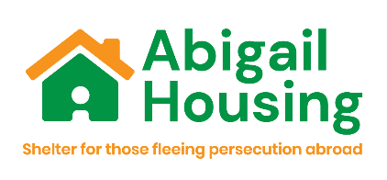
Abigail Housing Statement of Purpose
Abigail Housing is a charitable company limited by guarantee.
The registered charity address is Woodhouse Community Centre, 197 Woodhouse Street, Leeds, LS6 2NY.
Abigail Housing’s main contact email addresses and phone numbers are:
refugee@abigailhousing.org.uk 07743189314
asylumseeker@abigailhousing.org.uk 07908364112
Abigail Housing exists to relieve financial hardship amongst those seeking asylum, those granted refugee status, other vulnerable migrants and their dependants who are destitute and living temporarily or permanently in the Yorkshire and Humber Region, in particular but not exclusively by the provision of temporary accommodation, advice, information support and advocacy.
Abigail Housing’s purpose is to prevent destitution and homelessness; alleviate social exclusion; support with longer-term housing options; facilitate re-engagement with the asylum process and enable access to other services – promoting health, wellbeing, rights, entitlements and quality of life.

Abigail Housing operate two projects from two office locations in Leeds and Bradford:
Leeds Refugee Project: Woodhouse Community Centre, 197 Woodhouse Street, Leeds, LS6 2NY.
The Leeds Refugee Project provides accommodation and associated wrap around support to recently recognised refugees who have received a positive decision on their asylum claim and are at significant risk of homelessness after exiting the asylum system.
Bradford Destitution Project: Touchstone Methodist Centre, 4 Easby Road, Bradford, BD7 1QX
The Bradford Destitution Project provides accommodation and supports Appeals Rights Exhausted (ARE) asylum seekers, with no recourse to public funds who have become homeless and destitute because of their immigration status. ARE asylum seekers are supported to submit appeals and re-engage with the asylum system.

